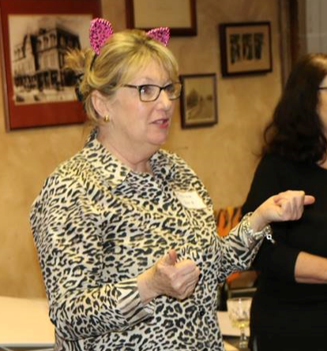

Whether you are a renewing member or first time member, I want to thank you for your membership and support. Since the founding of our organization in 1971, we have been furthering the fight for political gender parity. There is a long way to go, nevertheless, we persist. To give you an idea about what to expect going forward, here's a look back, at all we accomplished in 2016.

Membership meetings/community forums/fundraisers, included:
- Medicaid Expansion - What's at Stake?
- The Cannabis Debate - Is it Time to Legalize Marijuana in Missouri?
- The Earnings Tax - Update
- Immigration Reform -What's Happening in Kansas City?
- Meet the School Board Candidates
- Candidate Forum: Missouri House and Senate Candidates (endorsement vote)
- Trailblazers Event: Hall of Fame Awards went to Senator Jean Carnahan and Peggy Bowman. Spoken Word Performance by Natshi Ria-El Scari
- Candidate Forum: Kansas House and Senate Candidates (endorsement vote)
- Missouri State Convention
- Who is ALEC and Why Is He Writing So Much Legislation?
- Equality Week Family Picnic
- Sponsored "Equal Means - Equal" film at Union Station
- Torch Dinner and Awards Ceremony
- Coordinated Missouri Vote No! on Photo ID legislation with partners throughout the state
- Fundraiser for MO Statewide Candidates
- Forum on Ballot Issues
- Leadership Open House
- Nasty Women Rally
- Congressman Cleaver II - GOTV Rally
- Hosted Mayor Sly James - Women's Empowerment Initiative
- Holiday party with the Women in Politics Foundation
Thanks to all who participated in our events.

Following the outcome of the election and the threat the current administration poses to a broad swath of Americans, our volunteer board has been working in overdrive to rally the necessary support to ensure our voices are heard and we are represented. Our membership has more than tripled which has allowed the opportunity to increase the scope and impact of our actions.

The increase in participation has enabled us to form our Political Action Groups (PAGs) throughout the bi-state area. Our PAGs include: Eastern Jackson County, MO; Northland, Mid-town, South-town in KCMO; and Johnson, Wyandotte, and Douglas Counties in Kansas.
PAGs are semiautonomous groups whose representatives are elected by the members of the GKC/WPC Board of Directors. PAGs hold their own meetings, set programs, identify local school board/municipal/state open seats, and recruit/train/endorse progressive women to run for these positions. If you are not a member of a specific PAG, please check out our Facebook page: https://www.facebook.com/GKCWPC for more information on programming.

We kicked off 2017 with "The Women's March", setting a tone of solidarity with women and allies all over the nation and the world. Moving forward, we are using the strategies outlined by, "INDIVISIBLE": A Practical Guide for Resisting the Trump Agenda. This is a quintessential guide, written by former congressional staffers that reveal the best practices for making Congress listen.

At our first two membership meetings of 2017 we heard from our state(s) representatives on current legislation, practiced phone calling legislators, practiced "knocking on doors" for candidates, and heard from a representative from the "Indivisible" movement. In February, we held our first "campaign training" and "campaign volunteer" training of the year.
Our PAG meetings have included; poster making for the Women's March, hearing from legislators, grassroots organizing, a postcard writing campaign, phone banking with Missouri Jobs with Justice regarding Medicaid Expansion, and, we also heard from a panel of experts on, "Fake News: Fact or Fiction".

This is a snapshot of the events held, and an idea of the kind of programming you have to look forward to in the future. You will be receiving monthly email updates, and for up to the minute information be sure to check us out on our website: http://gkcwpc.org/ and Facebook page: https://www.facebook.com/GKCWPC . We look forward to seeing you at the monthly membership meeting held the fourth Thursday of every month. Thank you for your membership, we have a lot of work to do and with your help we can truly create lasting, sustainable change!

Best Regards,
Regina
Regina A. Weir
Membership Chairperson, GKC/WPC

